GCP Bucket Data Access on Sumner

Steps to access the GCP bucket data using singularity container from sumner

# Prerequisite

* Permission to access the bucket data. If not, email helpdesk@jax.org to request access the GCP project “jax-cube-prd-ctrl-01” bucket storage

# Commands

1. Login into sumner
2. Load singularity

module load singularity

1. Run gcp_sdk singularity container directly from Jax container registry

singularity shell shub://jaxreg.jax.org/cube/gcp_sdk.sif:latest

1. Inside the container, login to gcp

~/singularity> gcloud auth login

Here is the sample output

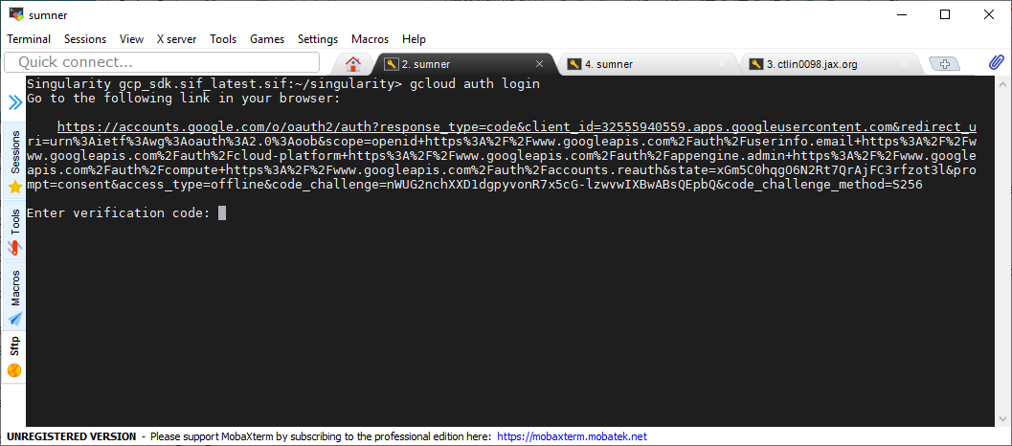

Copy and paste the URL into a browser, login into GCP and click on “Allow” button

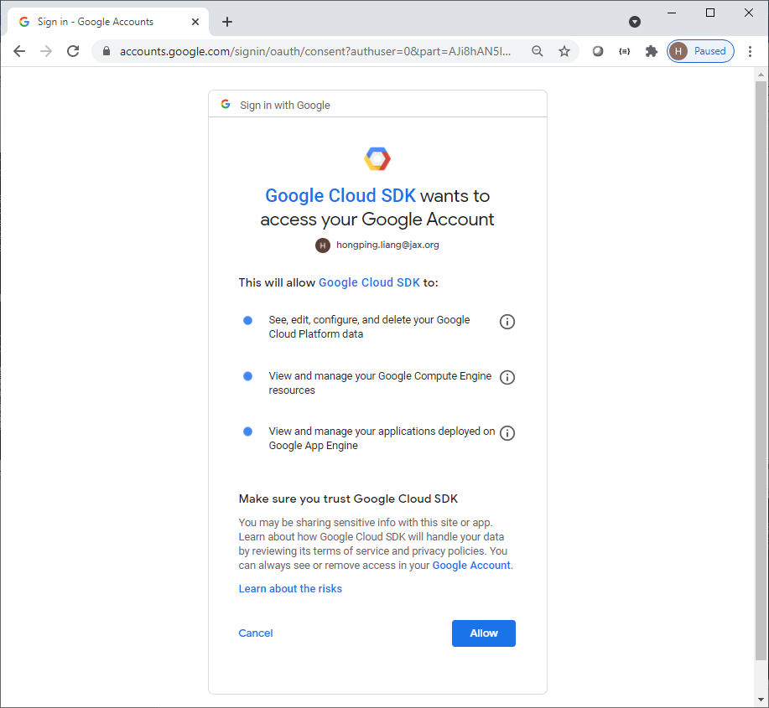

Copy the verification code and paste into the window

1. After login, list out the data

~/singularity> gsutil ls gs://jax-cube-prd-ctrl-01-project-data/

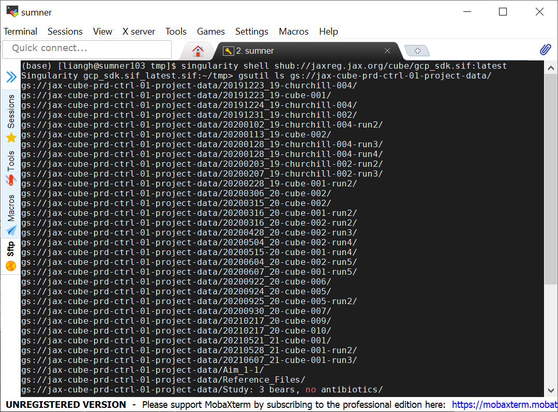

1. Copy a single file to local

gsutil cp gs://jax-cube-prd-ctrl-01-project-data/single_cell/MS19046/pipeline-metadata.json .

1. Copy files to local

gsutil cp gs://jax-cube-prd-ctrl-01-project-data/single_cell/MS19046/*.json .

1. Copy a directory to local

gsutil -m cp -r gs://jax-cube-prd-ctrl-01-project-data/single_cell/MS19046 .

-m option runs faster

After the exit from the container, the files should be in your current directory